🧪 PortSwigger Lab Write-Up

User ID Controlled by Request Parameter (APPRENTICE)

📌 Lab Information
- Lab Name: User ID controlled by request parameter
- Difficulty: Apprentice
- Category: Access Control / Horizontal Privilege Escalation
- Target Application: PortSwigger Web Security Academy

🎯 Objective
Exploit a horizontal privilege escalation vulnerability to obtain the API key of user carlos and submit it as the lab solution.

🔐 Given Credentials
Username: wiener
Password: peter

🛠 Tools Used
- Web Browser (Chrome / Firefox)
- Burp Suite (Community / Professional)
- PortSwigger Web Security Academy Lab Environment

🧠 Vulnerability Overview
The application uses a user-controlled request parameter (id) to identify which user account data is displayed.
The backend fails to verify whether the authenticated user is authorized to access the requested account, leading to horizontal privilege escalation.

🧩 Step-by-Step Exploitation

1️⃣ Login to the Application
- Log in using the provided credentials (wiener:peter).
- Navigate to My Account page.
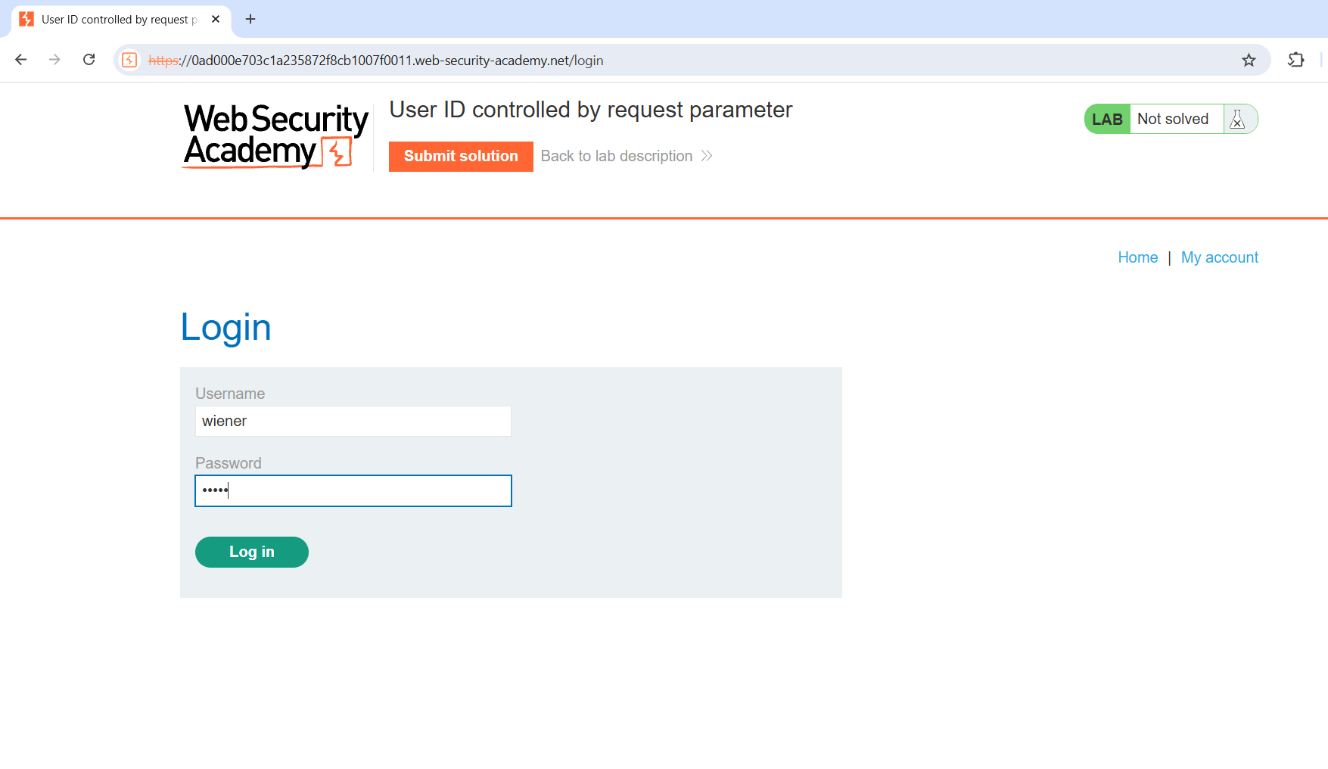

2️⃣ Observe the User ID Parameter
- On the account page, observe the URL:
/account?id=wiener
- The id parameter directly controls which user account is accessed.
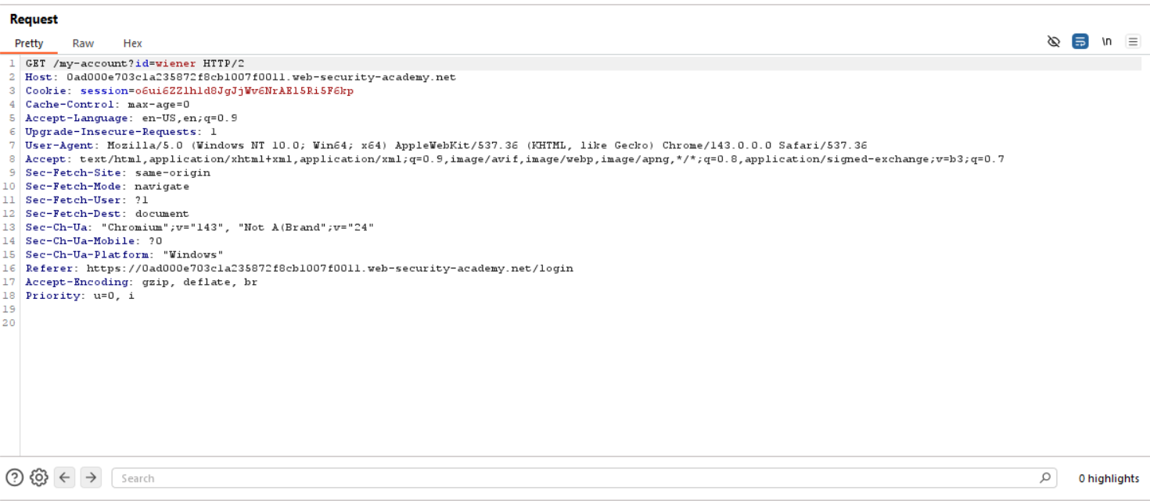

3️⃣ Send Request to Burp Repeater
- Enable Burp Proxy and refresh the account page.
- Capture the request and send it to Burp Repeater.
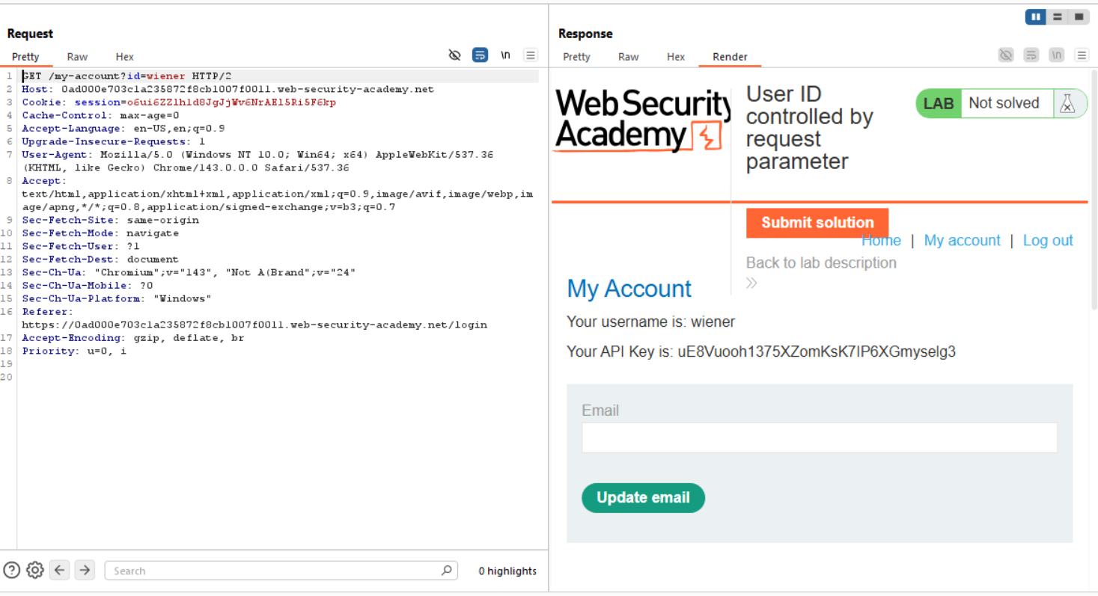

4️⃣ Modify the ID Parameter
- In Burp Repeater, modify the request parameter:
id=carlos
- Send the modified request.
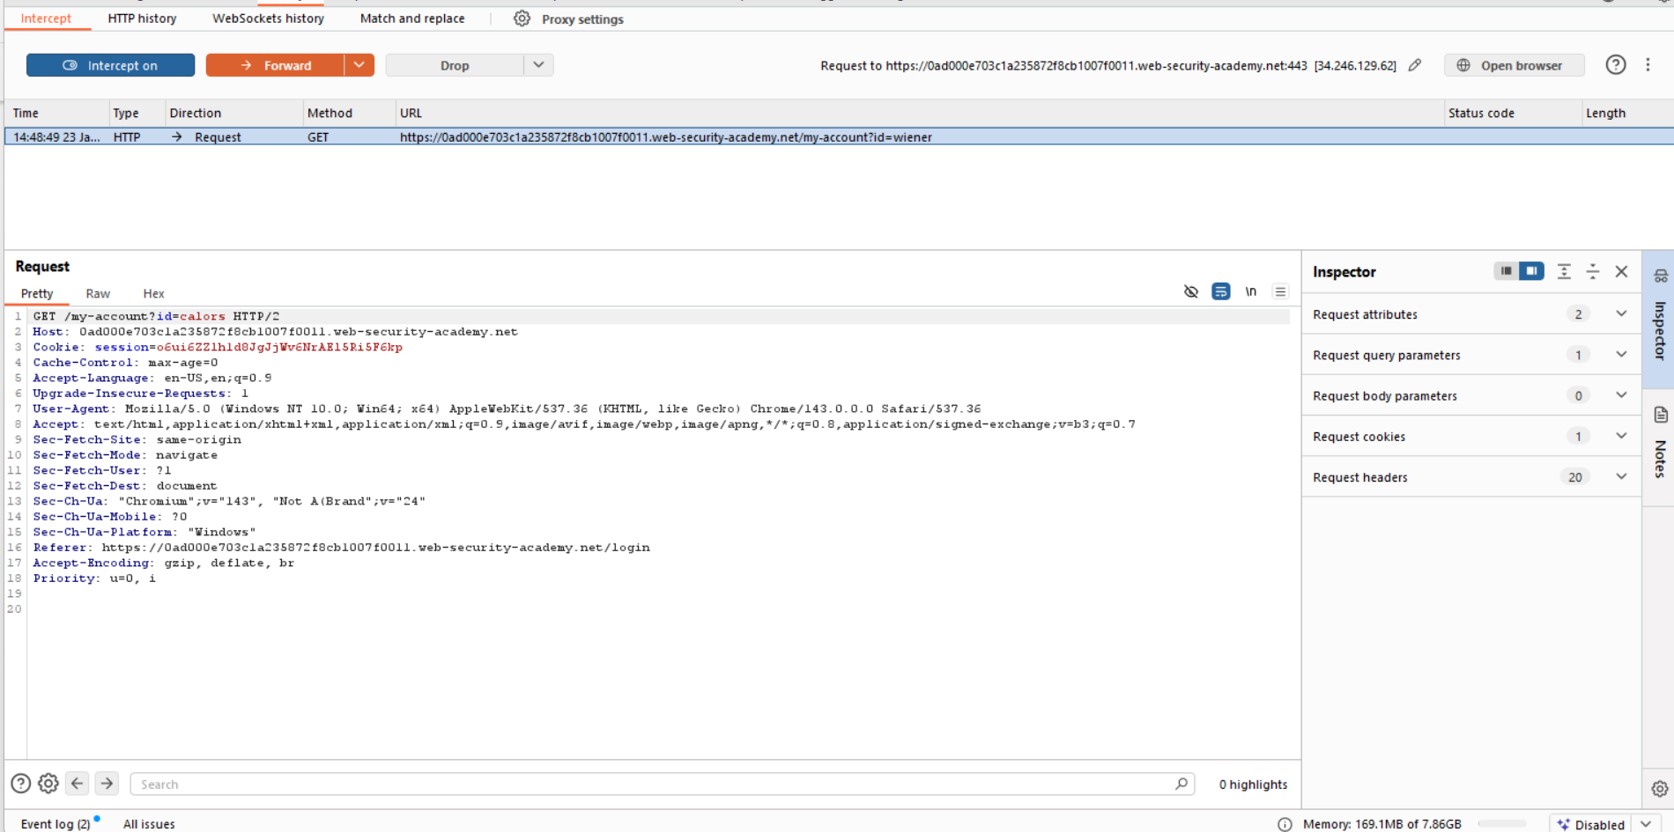

5️⃣ Retrieve Carlos's API Key
- Observe the response body.
- The application returns Carlos’s account details, including the API key.
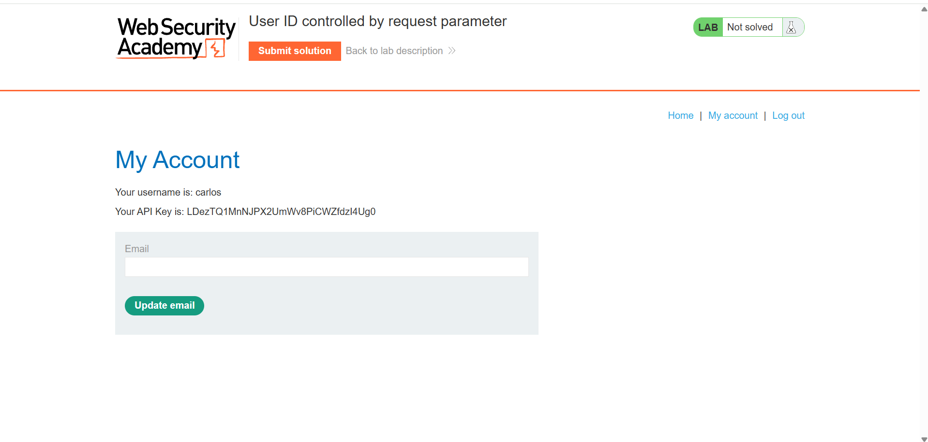

6️⃣ Submit the API Key
- Copy Carlos’s API key.
- Submit it in the lab solution field to complete the lab.
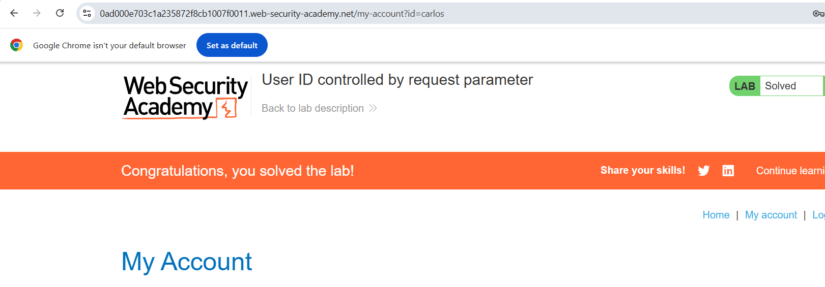

✅ Lab Status
✔ Lab Successfully Solved

🧯 Security Impact
- Unauthorized access to other users’ sensitive data
- Exposure of API keys and private information
- Potential account takeover and abuse of backend APIs

🔒 Mitigation & Recommendations
- Enforce strict server-side authorization checks
- Never rely on client-supplied parameters for access control
- Use session-based user identification
- Implement access control checks at every sensitive endpoint

🧑‍💻 Author
Chamika Jayasooriya
Cybersecurity Student | Web Security Enthusiast

